Bank Loan Report Query Document

1. BANK LOAN REPORT|SUMMARY|

KPI’S

Total Loan Applications

select count(id) as "Total Loan Applications" from banking_loan;

RESULT:

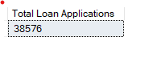

MTD Loan Applications

select count(id) as "MTD Total Loan Applications" from banking_loan

where month(issue_date) =12;

RESULT:

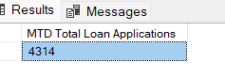

PMTD Loan Applications

select count(id) as "MTD Total Loan Applications" from banking_loan

where month(issue_date) =12;

RESULT:



TOTAL FUNDED AMOUNT

select sum(loan_amount) as "Total Funded Amount" from banking_loan;

RESULT:



MTD Total Funded Amount

select sum(loan_amount) as "MTD Total Funded Amount" from banking_loan where month(issue_date) =12;

RESULT:



PMTD Total Funded Amount

select sum(loan_amount) as "PMTD Total Funded Amount" from banking_loan where month(issue_date) =11;

RESULT:



Total Amount Received

select sum(total_payment) as "Total Amount Received" from banking_loan;

RESULT:



MTD Total Amount Received

select sum(total_payment) as "MTD Total Amount Received" from banking_loan where month(issue_date) =12;

RESULT:



PMTD Total Amount Received

select sum(total_payment) as "PMTD Total Amount Received" from banking_loan where month(issue_date) =11;

RESULT:



Average Interest Rate

select ROUND(Avg(int_rate),4) * 100 as " Avg Interest Rate" from banking_loan;

RESULT:



MTD Interest Rate

select ROUND(Avg(int_rate),4) * 100 as " MTD Avg Interest Rate" from banking_loan where month(issue_date) =12;

RESULT:



PMTD Interest Rate

select ROUND(Avg(int_rate),4) * 100 as " PMTD Avg Interest Rate" from banking_loan where month(issue_date) =11;

RESULT:



Average Debt Income Ratio

select ROUND(Avg(dti),4) * 100 as " Avg Debt Income Ratio" from banking_loan;

RESULT:



MTD Average Debt Income Ratio

select ROUND(Avg(dti),4) * 100 as " MTD Avg Debt Income Ratio" from banking_loan where month(issue_date) =12;

RESULT:

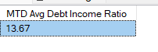

PMTD Average Debt Income Ratio

select ROUND(Avg(dti),4) * 100 as " PMTD Avg Debt Income Ratio" from banking_loan where month(issue_date) =11;

RESULT:



Good Loan Application Percentage

select (count (CASE WHEN loan_status = 'Fully Paid' OR loan_status = 'Current' THEN id END) *100)/ count(id)as "Good loan percentage" from banking_loan;

RESULT:



Good Loan Applications

select count(id) as “Good loan applications" from banking_loan where loan_status='Fully Paid' or loan_status='Current'

RESULT:



Good Loan Funded Amount

select sum(loan_amount) as “Good loan funded amount" from banking_loan where loan_status='Fully Paid' or loan_status='Current'

RESULT:



Good Loan Received Amount

select sum(total_payment) as "Good loan received amount" from banking_loan where loan_status='Fully Paid' or loan_status='Current'

RESULT:



Bad Loan Applications Percentage

select (count(CASE WHEN loan_status = 'Charged Off' THEN id END)*100)/count(id)as "Bad loan applications percentage" from banking_loan;

RESULT:



Bad Loan Applications

select count(id) as “Bad loan applications" from banking_loan where loan_status='Charged Off';

RESULT:



Bad Loan Funded Amount

select sum(loan_amount) as “Bad loan funded amount" from banking_loan where loan_status='Charged Off';

RESULT:



Bad Loan Received Amount

select sum(total_payment) as “Bad loan received amount" from banking_loan where loan_status='Charged Off';

RESULT:



GRID VIEW

select loan_status,

count(id)as "Total Loan Applications",

sum(total_payment) as "Total Amount Received",

sum(loan_amount) as "Total Funded Amount",

AVG (int_rate*100) as "Interest Rate",

AVG (dti*100) as "DTI"

from banking_loan group by loan_status;

RESULT:

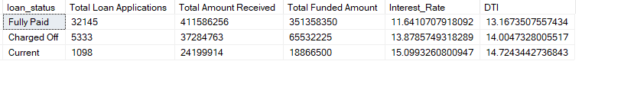

select loan_status,

sum(total_payment) as "MTD Total Amount Received",

sum(loan_amount) as "MTD Total Funded Amount"

from banking_loan where MONTH(issue_date)=12 group by loan_status;

RESULT:

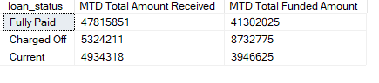

Monthly Trends by Issue_Date

select

MONTH(issue_date) as "Month Number",

DATENAME (MONTH, issue_date) as "Month Name",

count(id)as "Total Loan Applications",

sum(total_payment) as "Total Amount Received",

sum(loan_amount) as "Total Funded Amount" from banking_loan

group by MONTH(issue_date),DATENAME(MONTH,issue_date)

order by MONTH(issue_date);

RESULT:

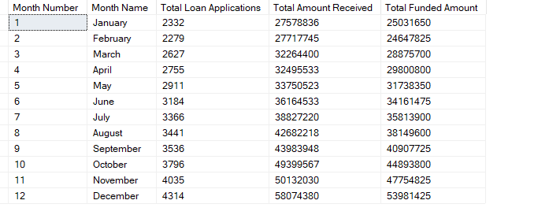

Regional Analysis by State

Select address_state,

count(id)as "Total Loan Applications",

sum(total_payment) as "Total Amount Received",

sum(loan_amount) as "Total Funded Amount" from banking_loan group by address_state order by address_state;

RESULT:

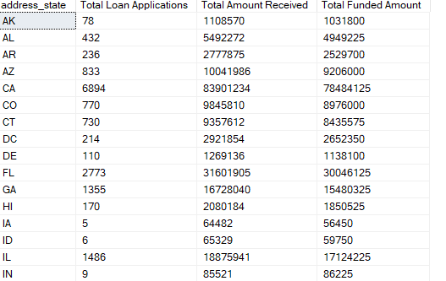

Loan Term Analysis

Select term,

count(id)as "Total Loan Applications",

sum(total_payment) as "Total Amount Received",

sum(loan_amount) as "Total Funded Amount" from banking_loan group by term order by count(id)DESC;

RESULT:

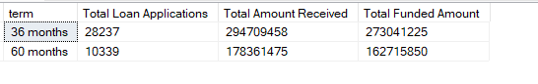

Employee Length Analysis

Select emp_length,

count(id)as "Total Loan Applications",

sum(total_payment) as "Total Amount Received",

sum(loan_amount) as "Total Funded Amount" from banking_loan group by emp_length order by count(id)DESC;

RESULT:

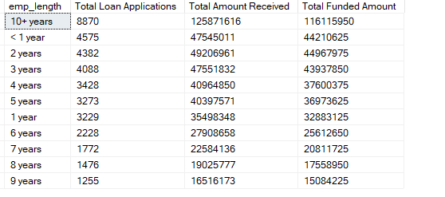

Loan Purpose Breakdown

Select purpose,

count(id)as "Total Loan Applications",

sum(total_payment) as "Total Amount Received",

sum(loan_amount) as "Total Funded Amount" from banking_loan group by purpose order by count(id)DESC;

RESULT:

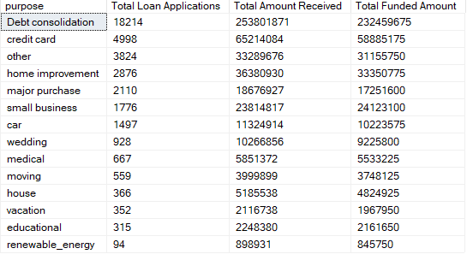

Home Ownership Analysis

Select home_ownership,

count(id)as "Total Loan Applications",

sum(total_payment) as "Total Amount Received",

sum(loan_amount) as "Total Funded Amount" from banking_loan group by home_ownership order by count(id)DESC;

RESULT:

